KSU-1 Senior Design

**3-D Printing**

The first step in creating this prosthetic is to 3-D print all the parts using optimized settings and orientations. The general layout of the parts and specific settings in Prusa Slicer are provided in the following figures below. Failure to follow the settings and orientations may result in failed prints or faulty parts. Note that each printer has unique capabilities, and thus the quality of the parts may vary depending on the device used to fabricate them.

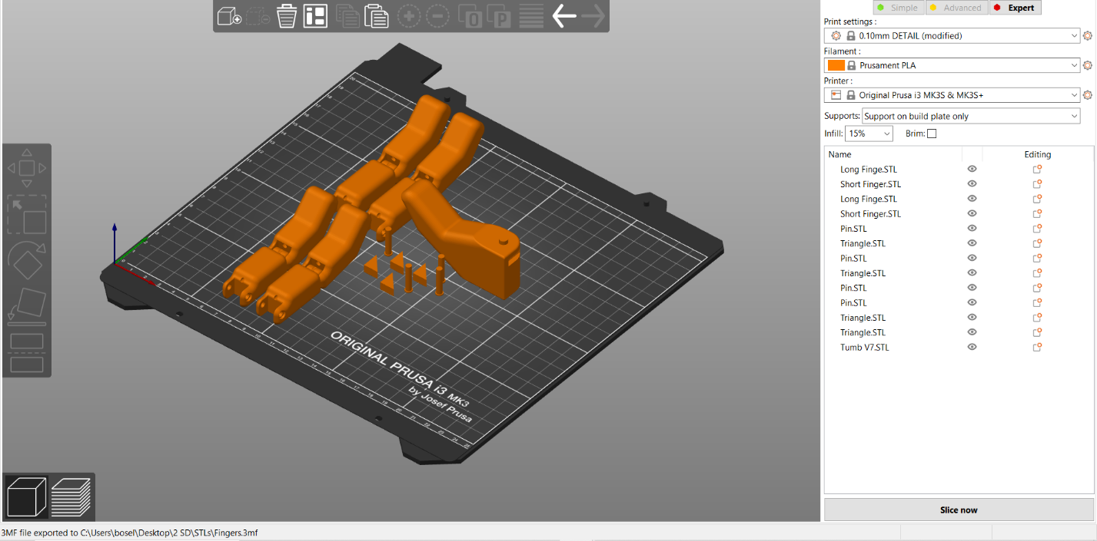Fig 1: Fingers Print

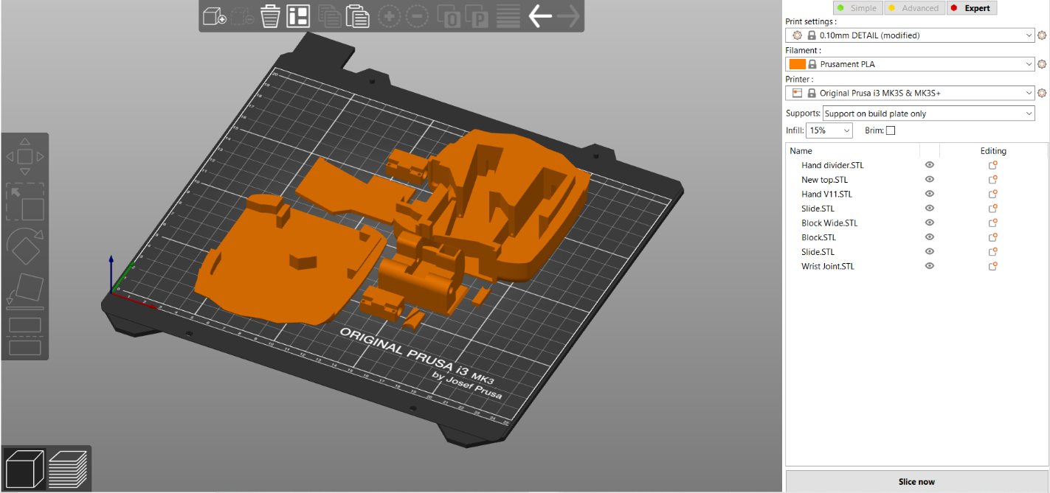Fig 2: Hand Print

Fig 3: Lower Forearm and Elbow Print

Fig 4: Upper Forearm Print

Once the prints have been completed, they should undergo basic post processing. This process includes removing the supports and sanding rough edges. Many of the parts utilize tight tolerances and friction fits, and thus some connections will require extra processing to properly function. Again, the quality and capabilities of each printer is unique, and thus some prints may require additional processing to function.

**Assembly**

Once all parts have been printed and processed, the full arm can be assembled. The following instructions outline the general assembly process, but some user discretion may be required depending on personal skill and tools available.

Hand

1. Connect the two longest fingers to the center two mounts of the hand using the small pins. Next, repeat the process for the smaller fingers on the outer mounts and remaining pins. If the friction fit of the pins fails, glue may be used to hold the pins in place.

1. Attach the rectangular slides to the shafts of the smaller linear actuators using the nuts and bolts provided with the actuators. Ensure the slides and travel smoothly within the hand.
2. Cut two strands of finger cable about 18 inches long. Thread the cable through the 3 holes on the slide (drill through if required) and pull the cable till it is halfway through. Thread the cable through the holes at the back of the channels for the slide. Thread the cable through to the tips of the fingers. Next, place the linear actuators into the hand with the slides facing the wrist.

1. Push the shafts of the actuators fully closed so the fingers are fully extended, while keeping extra cable exposed. Place the hand palm-down on a flat surface so the fingers stay fully extended. Ensure they stay fully extended for the following steps.
2. Tie the extra cable to the end of the fingers using the post at the end. Looping the cable once around the post before tying the knot may reduce excess cable and reduce the chance of the not untying. After tying the knot, a droplet of glue may be used to further solidify the connection, though this will make replacing the string very difficult later.

1. Put the triangle pieces into the gaps on the back of the fingers to lock the cable in place. This may require some light hammer taps and can be paired with glue to create a permanent hold.

1. Place the hand divider plate into the back of the hand under the wires coming from the actuators.

1. Thread the cable of the mg90 servo into the thumb, then insert the servo into the cavity. Place the thumb into the slots (the arm will insert into one end), then insert both thumb blocks to hold the thumb in place. Route the cable through the channel so it feeds out of the wrist.

1. Route the thumb servo and linear actuator cables through the wrist joint then slide the joint into the slot provided, ensuring the curved face of the joint faces the palm.

1. Place the cover onto the back of the hand and screw it into place.

Wrist

1. Connect all the wiring to the circuit board. This includes the battery, 3 linear actuators, 3 servos, the pressure sensors. Doing this now allows us to manage the cable as we continue assembling the arm.

1. Place the elbow actuator (with gear) into the elbow base so that it can be locked into place route the wire through the cable holes for later.
2. Once you are sure the wiring matches the attached wiring diagram place the circuit boards into their designated locations on the upper forearm (shown in photo) and use screw to ensure they stay in place.

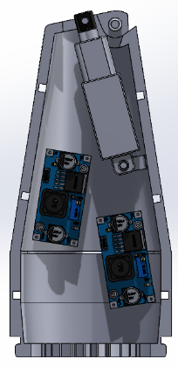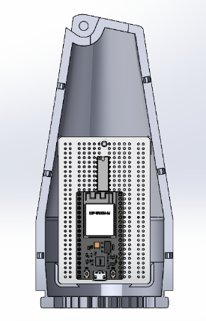

1. Take the wrist actuator and use the actuator pin to attach it to the wrist joint (this is the piece you already slotted into the bottom of the hand piece.
2. Place the wrist actuator in place in the upper forearm and use screw to attach it to post in the forearm. This will require putting the hand on the onto the post at the top of the upper forearm.

1. Line up both sides of the upper forearm to the wrist join and the lower forearm connection. Once everything is lined up and all the wires are inside press them together until the snaps lock everything in place.

1. Attach the wrist gear to the wrist servo and place it into either the male or female side of the lower forearm. Route both servo wires through the open space in the gears and clamp the opposite side of the lower forearm over the wrist servo, elbow base, and upper forearm. Make sure to line up the gear connection between the lower forearm and elbow base.

Parts List

|  |  |  |
| --- | --- | --- |
| Part | Description | Qty |
| **3D Printed** | | |
| Finger Long | Longer version of finger for Ring and middle fingers | 2 |
| Finger Short | Shorter Version of finger for pointer and pinky fingers | 2 |
| Pin | Pin to connect fingers to hand | 4 |
| Thumb | Thumb piece with move for servo | 1 |
| Block | Holds the thumb in place | 1 |
| Block wide | Holds the thumb in place | 1 |
| Triangle | Fits into back of fingertips to hold the cables in place | 4 |
| Hand | Hand piece holds hardware for finger movement | 1 |
| Hand Top | Lid for the hand hold everything in place | 1 |
| Hand Divider | Put into the hand piece to split apart mechanical movements and wiring | 1 |
| Slide | Attaches the linear actuators to the cables that move the fingers | 2 |
| Wrist joint | Connects the hand to forearm with passthrough for wires and mount for linear actuator that provides wrist movement. | 1 |
| Upper Forearm Male | Upper forearm outer shell | 1 |
| Upper Forearm Female | Upper forearm outer shell | 1 |
| Lower Forearm Male | Lower forearm outer shell | 1 |
| Lower Forearm Female | Lower forearm outer shell | 1 |
| Elbow Base | Structure of elbow that can be mounted to something else | 1 |
| Elbow Gear | Gear to transfer rotation from servo to elbow | 1 |
| Forearm Gear | Gear to transfer rotation from servo to forearm | 1 |
| Actuator Pin | Pin to attach actuator to the wrist joint | 1 |